Project Documentation

STORE MANAGER KEEP TRACK IN INVENTORY

# Introduction

## Project Title: STORE MANAGER KEEP TRACK IN INVENTORY

* + **Team ID:**   NM2025TMID47764
  + **Team Leader:** P DEEVADHARSHINI & deevadharshinideevadharshini1@gmail.com

## Team Members:

## DHANALAKSHMI R & dhanalakshmikavitha205@gmail.com

## DHARSHINI M & dharshiniusha18012007@gmail.com

## DHARSHINI S & dharshudharshu8806@gmail.com

# Project Overview

* + **Purpose:** This project involves the development of an **Inventory Management System** tailored for store managers to efficiently monitor, manage, and control stock levels in real time.

## Features:

* + - Real-Time Inventory Tracking

_ Stock In/Out Management

* + - Product Categorization
    - Inventory Reports & Analytics

# Architecture

* + **Frontend:** Built using a modern frontend framework (e.g., **React.js)**
  + **Backend:** Node.js and Express.js The backend follows a **REST full API architecture**

**Database: No SQL Database** for scalability or flexible data structures.

* Example: **Mongo DB**

# Setup Instructions

## Prerequisites:

# 

## __ react.js

## __ database

# 

# 

# 

# 

# 

## 

* + - Git hub
    - node.js
    - **v**isual Studio Code

## Installation Steps:

## # **Clone & Install Backend**

## # **Install & Configure Frontend**

## # **Set Up Database & Test**

# Folder Structure

SB-Works/

|-- client/ # React frontend

| components/ L pages/

| server/ # Node.js backend

| routes/

| models/

| controllers/

# Running the Application

## Frontend:

cd client npm start • **Backend:**

cd server npm start

* + **Access:** Visit [http://localhost:3000](http://localhost:3000/)

# API Documentation

## User:

* + - /api/user/register
    - /api/user/login

## Projects:

* + **Chats:**
* /api/projects/create
* /api/projects/:id • **Applications:** /api/apply
* /api/chat/send
* /api/chat/:userId

# Authentication

• Adding/removing products

• Viewing stock levels

# User Interface

* + Quickly check inventory levels
  + Add or remove stock
  + Manage products and suppliers
  + Generate and export reports

# Testing

* + Inventory tracking works as expected

• Only authorized users can access specific features.

Existing Solutions

Git Hub link [ <https://github.com/deevadharshinideevadharshini1-collab/store-manager-keep-track-in-inventory.git> ]

1. **Screenshots or Demo** 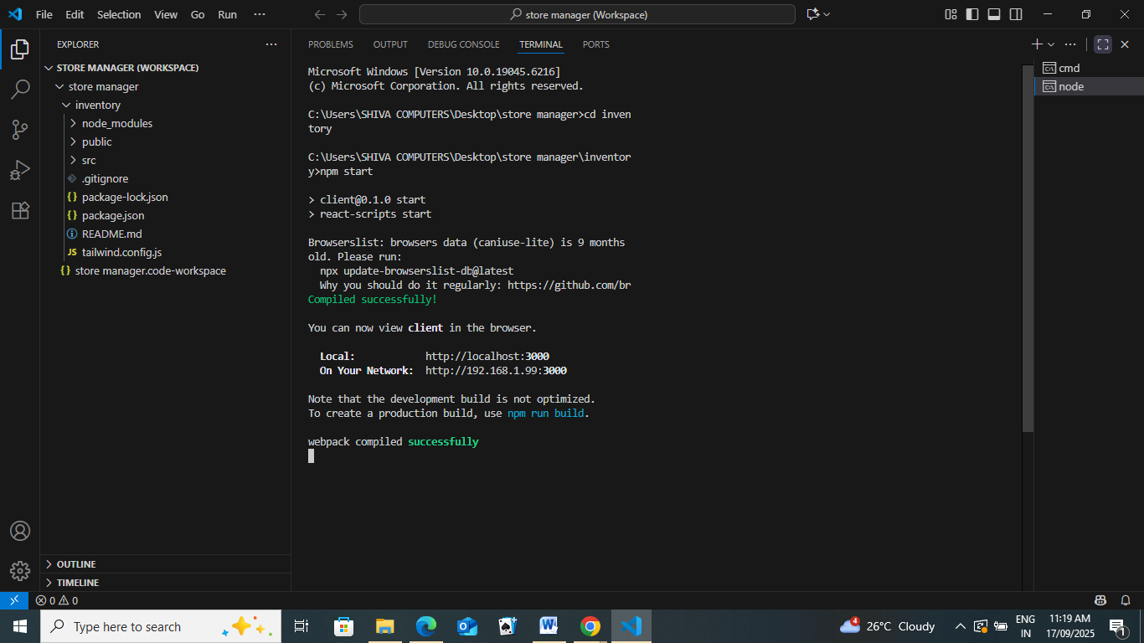
2. **Known Issues** The Store Manager Inventory Tracking System, while functional, currently has a few known limitations. Firstly, the system lacks features like email verification and password reset, meaning users cannot recover their accounts automatically. Product image uploads are not supported, limiting visual representation in the inventory. Role management is basic, offering only "manager" and "staff" roles without granular permission control. Additionally, the system does not function offline and does not support real-time syncing, requiring manual refreshes to see updates
3. **Future Enhancements** To further improve the functionality, security, and usability of the Store Manager Inventory Tracking System, several enhancements are planned for future development. One key improvement is the addition of email verification and password reset functionality to enhance account security and user convenience. Support for product image uploads will be introduced, allowing managers to visually identify items. The system will also be expanded to include advanced role-based access control (RBAC), enabling more flexible user permissions beyond the current manager/staff roles.